
School of Computing and
Mathematical Sciences

BSc Final Year Project Form

- Proposal
The student should complete parts 1(a), 1(b), 1(c) and 1(d) below. An electronic version of this form should be uploaded to the Final Year Project module on Moodle no later than the module deadlines specified on the BSc module on Moodle.

(a) Student details
Name:  Email: | Type 4: BUCI072S6 BSc Data Science project  Alnung2006@gmail.com

(b) Project details
Title: Inventory Management System for a Retail Store to optimise inventory
Objectives:
The aim of this project is to develop a comprehensive inventory management system for retail stores that ensures efficient, real-time tracking of stock levels and seamless data management using MySQL and Python. This system will provide essential features for storing and managing inventory, sales, and supplier data while offering advanced functionalities like automated reorder alerts to help prevent stock shortages. Additionally, the project aims to deliver data analysis and visualization tools to generate insights into sales trends and inventory movement, enhancing strategic decision-making. A user-friendly interface will simplify usage for retail staff, while role-based access control (RBAC) and audit logs will improve security and accountability by managing user permissions and tracking actions within the system.
- Real-time Inventory Tracking (Essential): Implement a system allowing retail stores to monitor stock levels and product movements in real-time.
- Data Management (Essential): Design a robust database using MySQL to efficiently store and manage data related to products, inventory, sales transactions, and suppliers.
- Data Analysis and Visualization (Desirable): Analyse sales trends and stock movements, providing actionable insights through visualizations.
- User-Friendly Interface (Desirable): Develop an intuitive interface enhancing user experience and simplified inventory management for retail staff.
- Role-Based Access Control (RBAC) (Desirable): Implement user roles with permissions.
- Automated Reorder Alerts (Optional): Implement an automated system that send alerts when stock levels fall below a pre-determined value.
- Audit logs (Optional): Track user actions which can be exported within SQL.
Problem description/Background:
While there are similar solutions on the market such as Enterprise Resource Planning systems (e.g. SAP, Orace, Sage), pre-built inventory management tools (e.g. Zoho, QuickBooks, Orderwerks) and Point-of-Sale systems (e.g. Square, Shopify, Lightspeed) they have limitations which can be solved with the system to be created. Potential limitations of existing solutions include being overly complex, having a high initial investment and ongoing fees, increased costs if extra capabilities or capacity required, lack of flexibility and requiring internet connection. The proposed solution can remedy the majority solutions due to it being custom made for the client so it can be as simple or complex as required, no increase in ongoing costs and the provision of data analysis built in for enable more effective stock management.
Retail inventory management systems can be a complex task, particularly for businesses dealing with large volumes of products and frequent sales transactions. Traditional inventory systems often lack real-time updates, leading to issues such as stockouts, overstocking, and inefficient use of resources. This project addresses these challenges by creating an Inventory Management System that provides:
- Accurate tracking of stock levels to prevent stockouts and excess inventory.
- Detailed records of product movements to streamline the supply chain.
- Analytical tools to help retailers make informed decisions based on sales data.
Methodology and Methods:
- System Design and Architecture
- Develop use case diagrams to illustrate system functionalities, such as updating inventory, processing sales, generating reports, and issuing alerts.
- Create class diagrams to define system components and their relationships, focusing on entities like Product, Inventory, Transaction, and Supplier.
- Outlining the workflow for key processes like inventory updating and data analysis.
- Data Flow Diagrams (DFD): Map data flow between system modules, illustrating how data moves from the UI to the database, is processed by Python scripts, and then returned as visualized output.
- Database Development (MySQL)
- Design a database schema to minimise data redundancy. Tables include:
  - Products: ProductID, Name, Category, and Price.
  - Inventory: ProductID, StockLevel, and LastUpdated.
  - Sales Transactions: ProductID, QuantitySold, SaleDate, and SaleTotal.
  - Suppliers: SupplierID, Name, Address, Number, and LeadTime.
- Data Constraints: Implement primary keys, foreign keys, and unique constraints for data integrity.
- Triggers: Use triggers to automatically update inventory levels when new transactions are recorded.
- Python Script Development
- Write a script connecting to the MySQL database to update stock levels after each sales transaction.
- Use Pandas and SQLAlchemy to pull sales data from MySQL, then process and analyse the data for metrics like sales frequency, seasonal trends, and turnover rates.
- Use Matplotlib to create visualisations for sales trends, and heatmaps for stock levels across categories, which will be presented via a dashboard interface
- User Interface Development
  - For the IU, either Flask or Dash will be used to create a dashboard
  - It will be designed for ease of use, displaying key metrics, real-time stock levels, and a search function to find specific product information.
- Testing
  - Conduct unit testing to test individual functions and validate data consistency in SQL
  - Conduct integration testing to test interactions between different components with different tasks
  - Conduct UAT to get feedback from potential users regarding usability, performance and effectiveness

Risks:
The potential risks are:
- Errors in data entry, stock levels or database structure can lead inaccurate inventory which can impact reorders. To mitigate this, validation checks and data constraints can be implemented, automating data entry where possible to reduce human error risks and regular audits.
- System performance could slow down due to increased database size or system crashes. To mitigate this, Queries can be optimised using large data sets to simulate increased workloads.
- Unauthorised system access can lead to data breaches or system misuse. To mitigate this, a secure RBAC can be implemented to restrict user permissions and regularly review security protocols.
- Hardware or software failures, or accidental deletions can lead to loss of important data. To mitigate this having regular backups and establish data recovery protocols.
- Integration issues when setting up functionality or connecting python to SQL. To mitigate this, conduct regular integration testing during development to identify and solve issues.
Work plan with time estimates:
- Project Planning and Requirements Gathering - 2 weeks
- System Design (UML Diagrams) - 1 week
- Database Design and Development - 2 weeks
- Python Scripting for Automation - 3 weeks
- Data Analysis and Visualization Development - 2 weeks
- System Integration and Unit Testing - 2 weeks
- User Training and Documentation - 1 week
- Final Review and Adjustments - 1 week
- Total Duration - 15 weeks
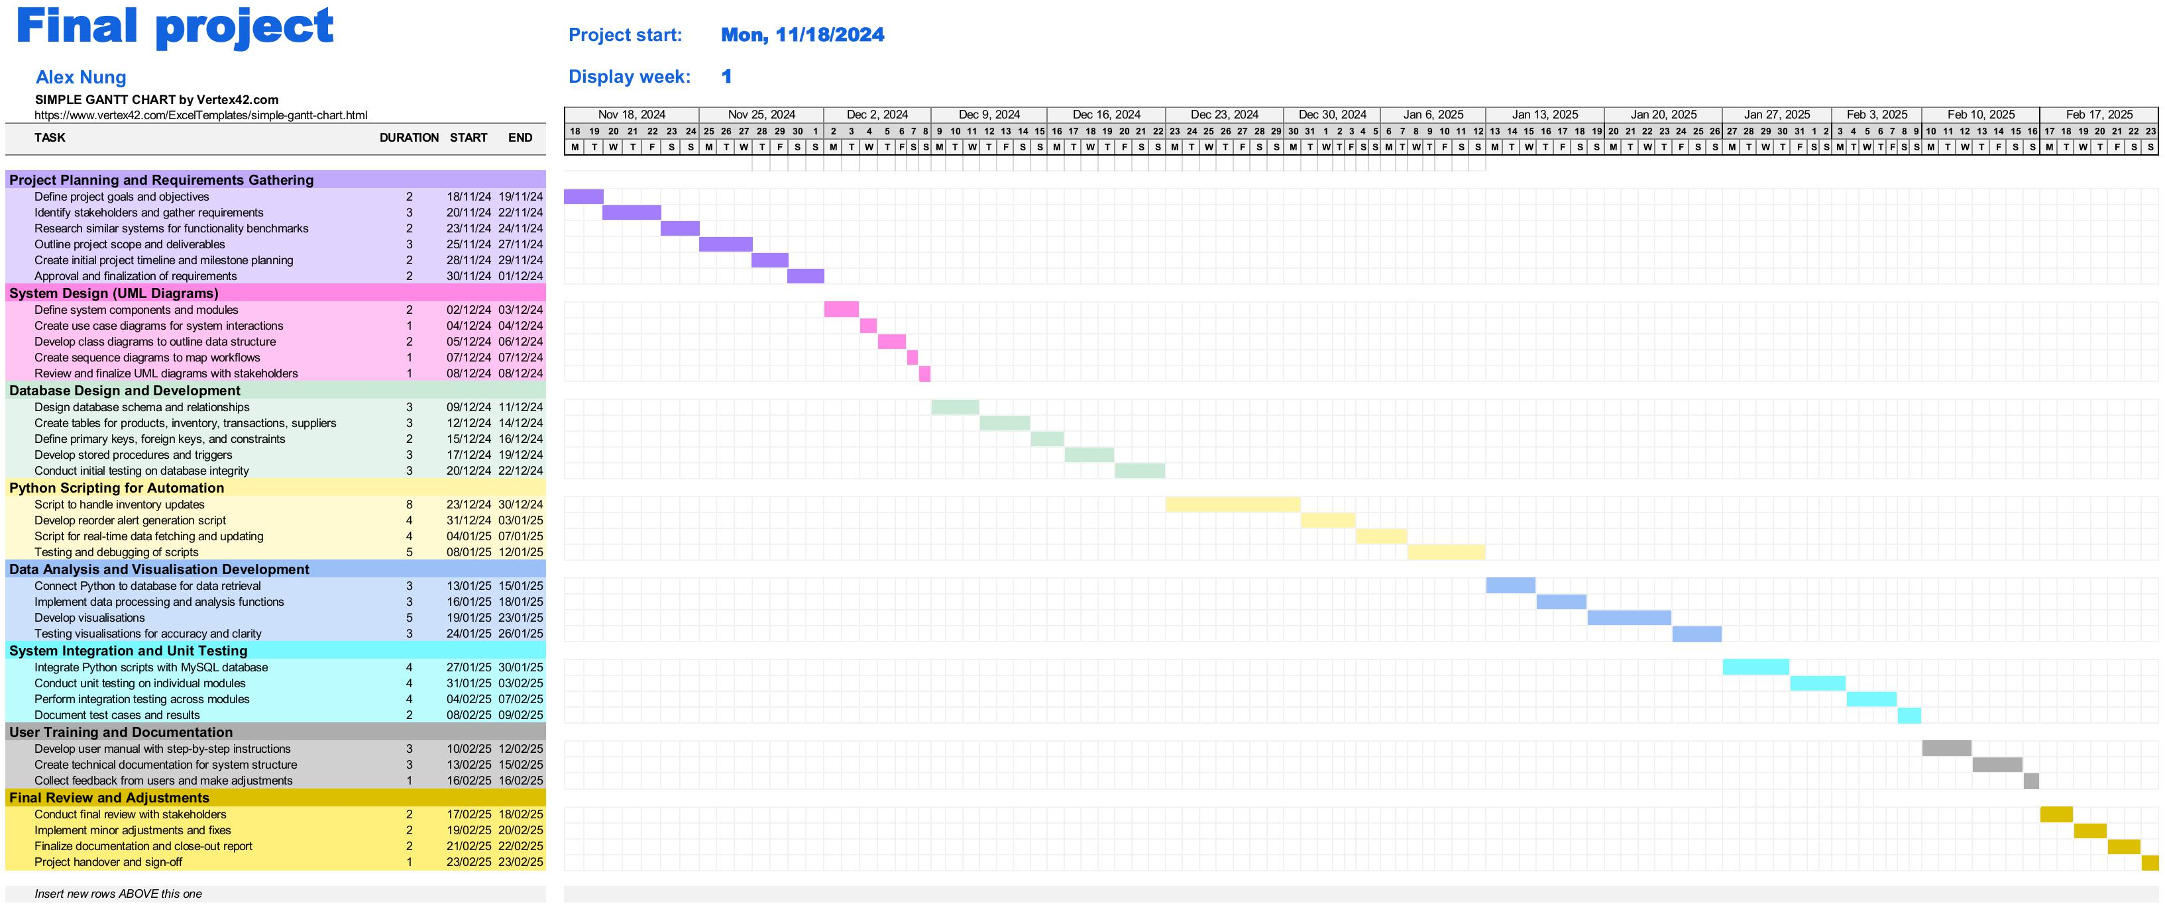
[1] – Gantt Chart template [https://create.microsoft.com/en-us/template/simple-gantt-chart-4bf6b793-490f-4623-84ca-c9c6251a91fc]
College equipment required:
None (Using personal with Python and SQL installed)

(c) Ethical issues
Has the student consulted the guidelines on research with ethical implications? yes.
See “Key Information” tile on Moodle: https://moodle.bbk.ac.uk/course/view.php?id=44270

(d) Supervisor details
Name: Dimitrios Airantzis | Date agreed:7th November 2024
- Proposal and Report Marking

Please note the following descriptions of projects of types 2, 3 and 4, as given in the Project Briefing document.

Type 2: Information Systems Research projects (BSc in ISM only)
An Information Systems Research project involves the investigation of information systems phenomena usually using interpretative research methods such as case studies or action research. Often the phenomena are newly emergent technologies and their social settings, development approaches or some aspect of the success or failure of an information system. Students who are considering a Type 2 project must take the module Research Methods in Management prior to enrolling for the project module. Supervision is carried out by the SCMS.

Type 3: Information Systems Development projects
An Information Systems Development project could involve the requirements capture and design of an information system or the evaluation of an existing system in order to identify problems and suggest improvements. Code may be written to check the feasibility of requirements or for comparison with existing code. Supervision is carried out by the SCMS. Any code implemented during the project must be demonstrated to the supervisor and supplied on a disk or USB memory.

Type 4: Computing projects
A Computing project involves the use of one or more programming languages for implementing a system or for investigating particular algorithms and data processing methods or for investigating computer based models of natural or artificial phenomena. Supervision is carried out by the SCMS. Any code implemented during the project must be demonstrated to the supervisor and supplied on a disk or USB memory.

BSc project submissions are evaluated against five criteria, as shown in the table below. Default weights per criterion are used, namely 15%, 15%, 50%, 20%.

Marks and feedback appear on Moodle. Please note that any marks shown on Moodle are the original marks, i.e. no capping due to late submission, penalty due to plagiarism allegation or other assessment offence is applied to marks shown on Moodle.

The marking scheme provided below is for information only. Project submissions are marked online, i.e. markers complete parts (a) and (b) of the table shown below online using marking forms provided on Moodle. Fixed weights for the marking criteria, as shown below, are used.

- Marker’s report

First/Second/Third Marker [Delete as appropriate]  Name: | Date received:
Criterion A: Proposal

Mark ............ out of ....15%....
Criterion B: Awareness and understanding of related work

Mark ............ out of ....15%....
Criterion C: Achievement, taking into account the difficulty of the project and also including but not limited to
Type 2: understanding and investigation of information systems phenomena
Type 3: requirements capture, design or evaluation of an information system
Type 4: design, layout and effectiveness of the code. If you are the supervisor, then indicate when you saw the code demonstrated.

Mark ............ out of ....50%...
Criterion D: Grammar, spelling, structure and coherence of the report, ability to present complex or technical material

Mark ............ out of ....20%...
Date returned: |  | Total ............ out of 100%

- Student feedback

Feedback is provided on Moodle. Markers fill in the corresponding fields in the Marking form on Moodle. When marks become available, students should check the "Grade column" on Moodle- mark will be shown out of 100. To read the feedback students should click on the Turnitin icon to access the Turnitin Feedback Studio- then click the "Rubric/Form" icon (right side panel on Turnitin) to access the feedback.

